

**Kulliyah Of Information & Communication Technology**

**CSC 1103:** **Object Oriented Programming**

**Semester 1, 2018-2019**

**Section: 5**

**Group Project Report**

***Title: Gold Shop Management System***

**Prepared By: Javanese**

|  |  |
| --- | --- |
| **Amin Nurul** | 1630645 |
| **Hasan Md Tanvir** | 1716763 |
| **Yahia Siddique** | 1639835 |
| **Shariful islam** | 1619061 |
| **Zannat Nahrin** | 1632738 |
| **Rakibul Islam** | 1520173 |

**Submitted To**:

**Noor Azura Binti Zakaria**

**Introduction:**

The name of our project is Gold shop management system. The tasks of this system is to manage the records of sell ,inventory and employee list and bill creation. The sell option is only for creating bills. Our java program shows two options when the program opens those are Sell and admin page. After pressing the sell option inventory will be visible and employee can create bills. In admin page the admin can update and check employee list, sells list, help ,change password. Data are being kept in a database. Admin can load any data at real-time from database. We created 8 buttons in total for this project.

**Project Scope:**

1. Easy to handle.
2. Don’t need any other tool except Java to run this system.
3. User experienced GUI
4. Secured
5. Organized database

**User:**

1. Manager of the shop
2. Verified employee of the shop

**Lessons learned from the project:**

1. How to create interface using java.
2. How to do the coding part.
3. How can you use the billing system.
4. We face some troubles regarding the project and we take help from youtube and google. So this will help us to increase our knowledege.
5. We can implement this in further processes like making other system easily, or improve this system take it to the another level. Make it more complex and user friendly.
6. We have learned how to use inheritance. Also how to create subclass and superclass

**Class Diagram:**

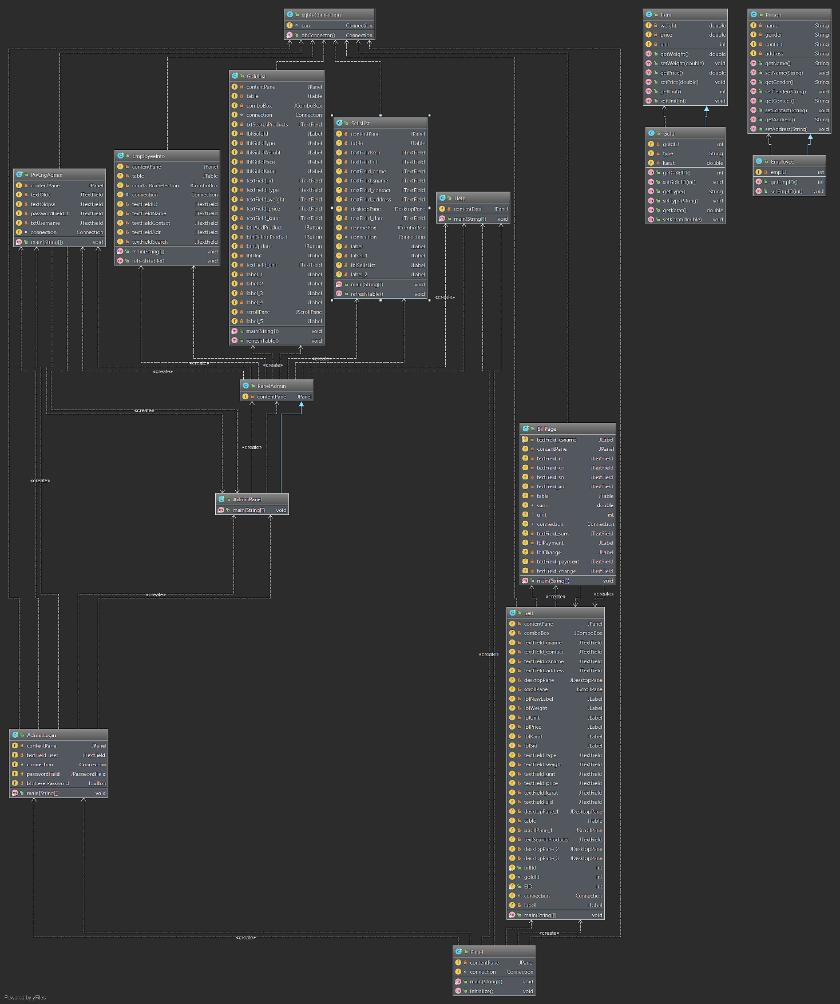

**Inheritance:**

**Super Class:** 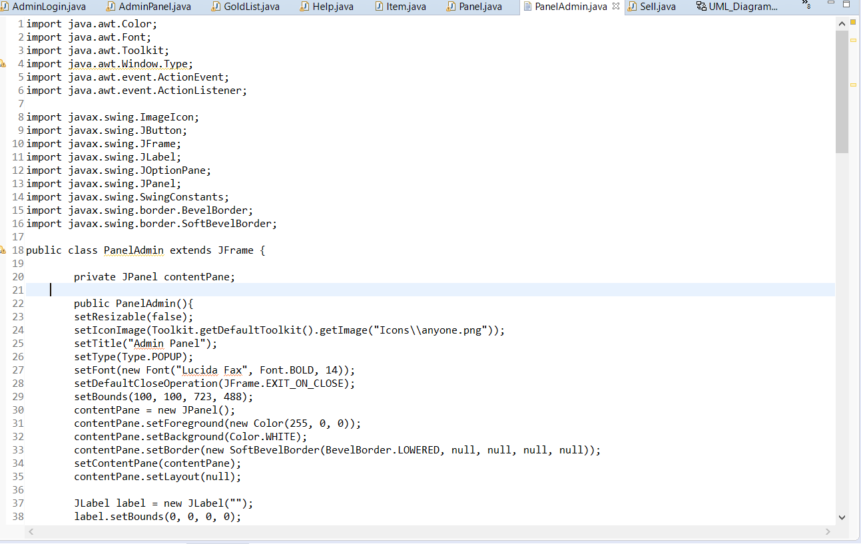

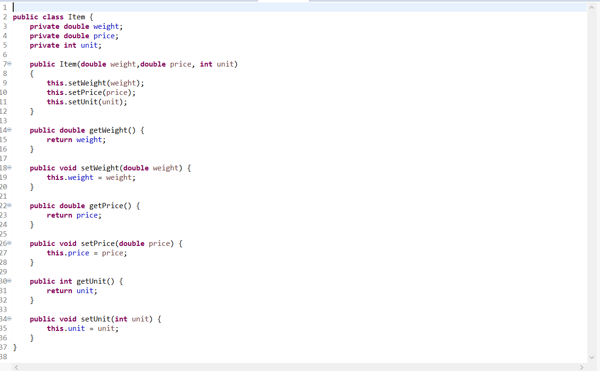

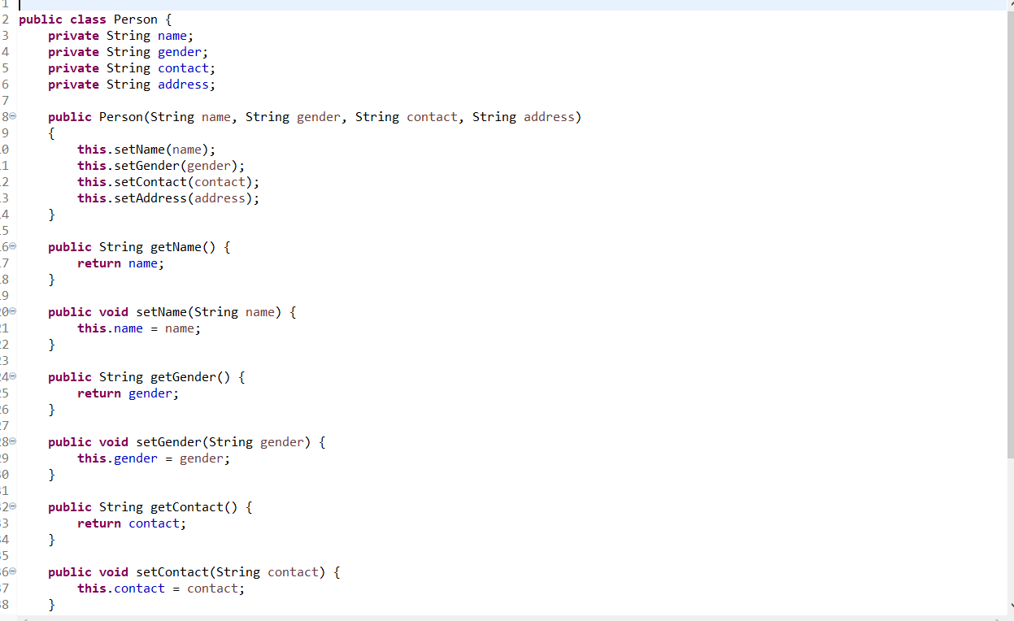

**Subclass:**

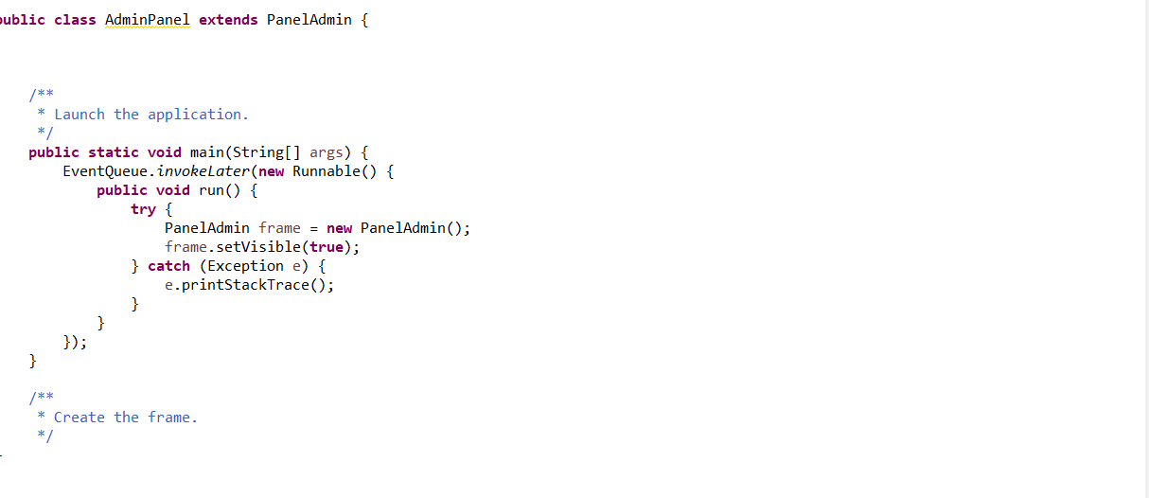

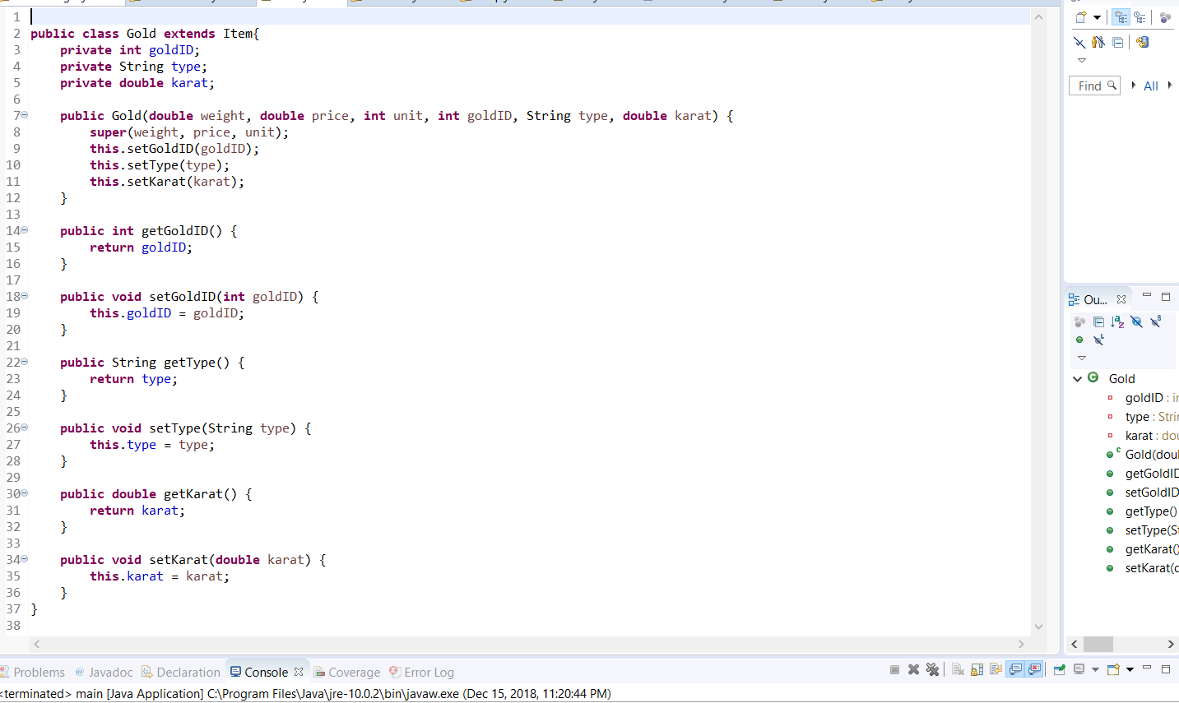

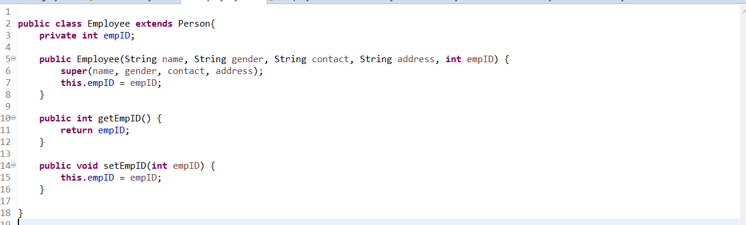

**Screenshot of the GUI:**

**Home Interface**

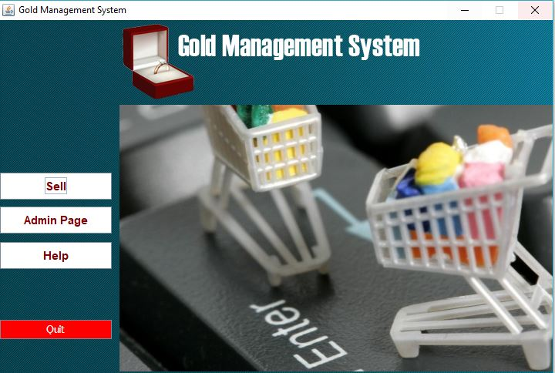

**Sell page**

**Function: Creating bills, show inventory**

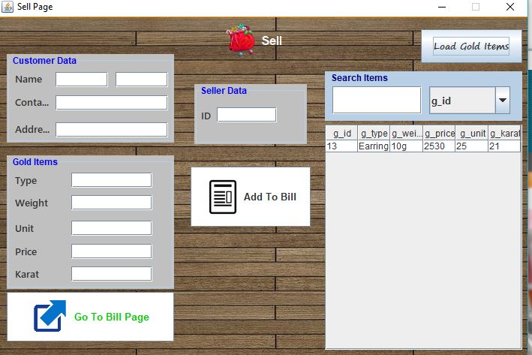

**Log in option for admin**

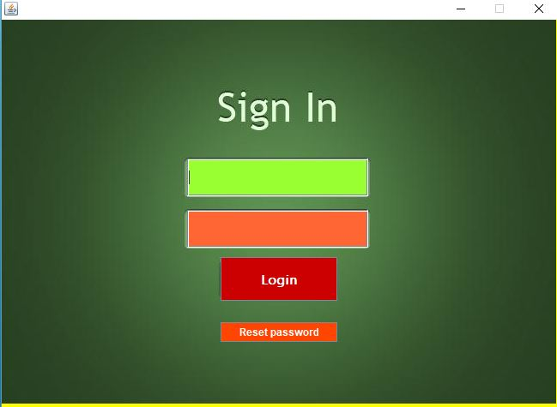

**Admin panel**

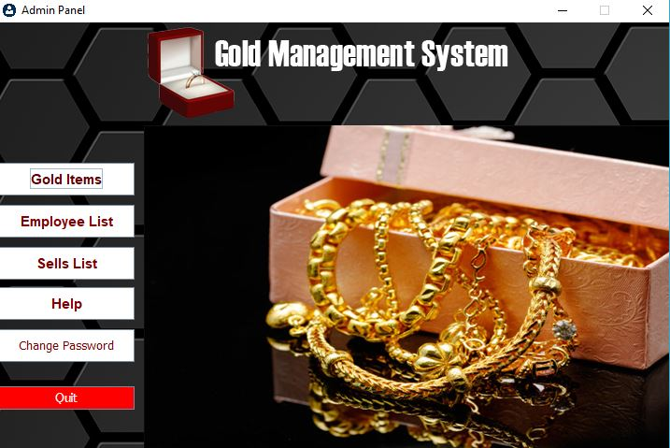

**Inventory input**

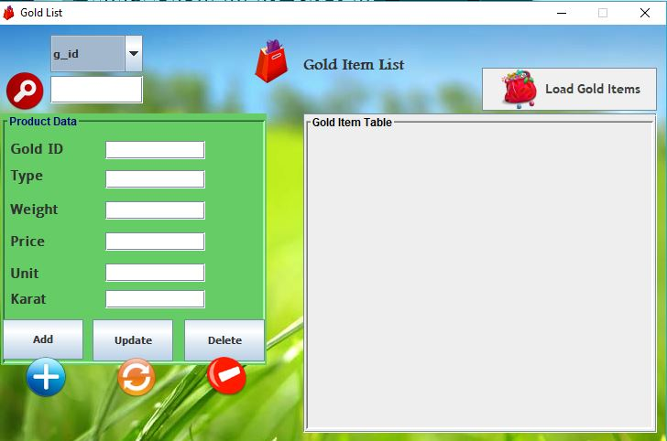

**Employee list**

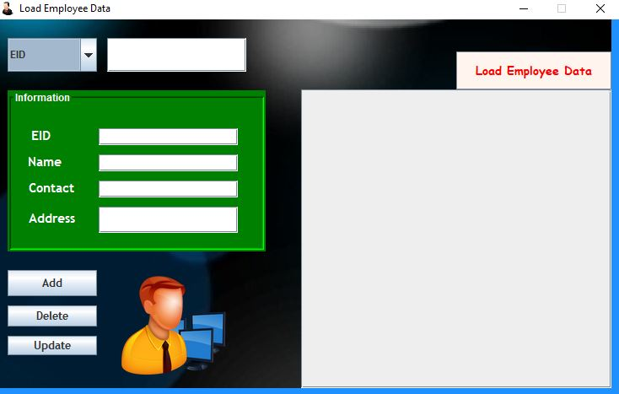

**Sells list**

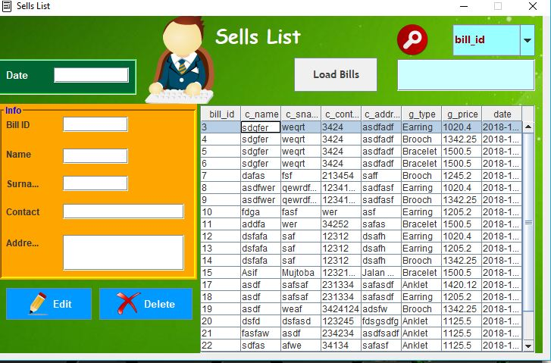

**Help GUI**

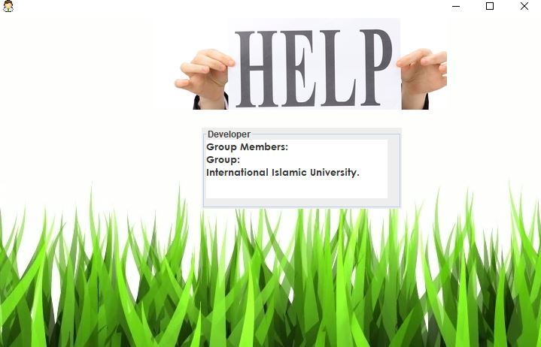

**Change password**

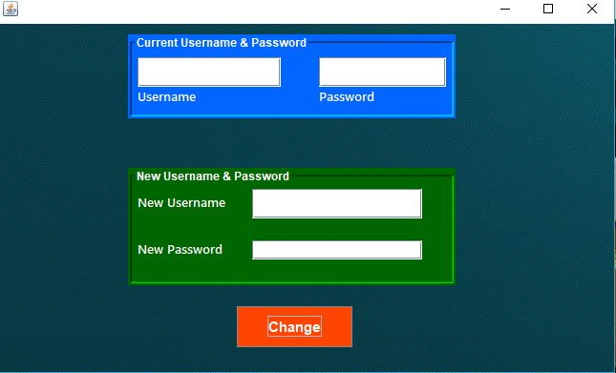

**The task distribution:**

|  |  |
| --- | --- |
| **Task** | **Member Name** |
| 1. **Design of interface** | Amin Nurul,Hasan Md tanvir, Yahia Siddique |
| 1. **UML Class Diagram** | Zannat Nahreen, Shariful Islam,Rakibul |
| 1. **Coding of buttons and logics**   -active it  -run code  -mouse clicked action performed  -calculating | Amin Nurul, Md Tanvir,  Sharif,Zannat Nahreen,Shariful Islam |
| 1. Inheritance | Amin Nurul |
| 1. Overloading | Yahia Siddique |
| 1. Overriding | Shariful Islam |
| 1. Database | Md Tanvir |
|  |  |

**List of challenges Faced.**

1. Regarding the design we don’t actually know how to use several boxes. So we take help from google and youtube and also the slides.
2. To compare with the UML class and Inheritence part we faced problem to run our code
3. To calculate overall total and subtract it from cash, we don’t know the method which have to use.
4. To create the exit button we take help from google to write down the code.
5. To clear all of the text field after clicking the Reset button , For this thing we take help from Youtube to see how the codes work.
6. While run the project the total button is not working properly, so we take time to find the problem.

**References and got help from:**

1.slides

2.youtube

3. google

**…….END……**